**Andhra Pradesh**

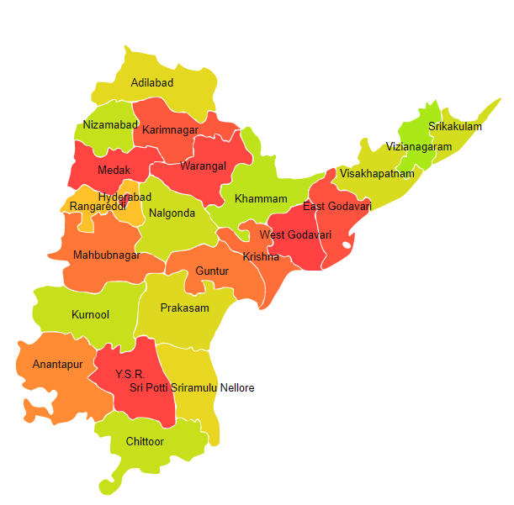

Andhra Pradesh comprises of five Agro Ecological Regions (AER) namely 3, 7, 8, 12 and 18.

**Agro-Eco Region 3 :** AER 3 in Andhra Pradesh comprises of Ananthapur district of Deccan Plateau under Agro Ecological Sub Region (AESR) 3.

**Agro-Eco Region 7 :** AER 7 in Andhra Pradesh comprises of Cuddapah, Guntur, Krishna, Kurnool, Nellore, Prakasam and West Godavari districts of Deccan (Telangana) Plateau and Eastern Ghats under Agro Ecological Sub Regions (AESR) 7.1 & 7.3.

**Agro-Eco Region8 :** AER 8 in Andhra Pradesh comprises of Chittoor district of Eastern Ghats under Agro Ecological Sub Region (AESR) 8.3.

**Agro-Eco Region 12 :** AER 12 in Andhra Pradesh comprises of East Godavari district of Eastern (Chhotanagpnr) Plateau and Eastern Ghats under Agro Ecological Sub Region (AESR) 12.1.

**Agro-Eco Region 18 :** AER 18 in Andhra Pradesh comprises of East Godavari, Krishna, Nellore, Prakasam, Srikakulam,Vishakhapatnam, Vizianagaram and West Godavari districts of Eastern Coastal Plain under Agro Ecological Sub Regions (AESR) 18.3 and 18.4.